
Session 5 Supporting Material
Secure by Design and Reusable Patterns. Reference for Activities 1 to 3.
Fictional organisation and synthetic data: the organisation, its people and its figures are invented for teaching.
Use the part each activity names. Nothing here is an answer to the activities: Part A is the design you review, and the worked examples use different systems.
Part | Contents | Used in
A | The agency's draft design: design notes, a requirements checklist, the class diagram (Figure 1) and the sequence diagram (Figure 2) | Activities 1 and 2
B | Reading a design: four passes, a severity scale and a worked example on a different system | Activity 1
C | Pattern cards (Strategy, Observer, Factory Method, Repository) and a draw.io quick guide | Activity 2
D | Writing an architecture decision record, with a worked example | Activity 3

Part A: The agency's draft design
Kestrel Moor asked its external agency to design two Phase 1 features: photo upload when a tenant reports a repair, and appointment notifications. Nothing has been built yet. The notes say what the agency intended; the diagrams (Figures 1 and 2, on the next two pages and in the starter file) show what it designed.
Agency design notes (draft 0.3)
Where each part runs. ReportRepairPage runs in the tenant's browser and TriageScreen in the adviser's browser. ContractorJobView runs on the contractor's tablet. Every other class runs on the portal server.
Photos. Tenants can add up to three photos when they report a repair. The page checks each one before upload, so tenants get instant feedback on a weak mobile signal. Photos are stored in cloud storage, one folder per request.
Contractors. The job view gives engineers everything they need for the visit on one screen.
Notifications. Tenants are told when an appointment is booked or changed, by the channel they prefer. Emergency appointments are confirmed by text.
Priority. The tenant sees the priority of their repair as soon as they submit it.

Requirements checklist (full wording in Case Brief Part 5)
Ref | Requirement
SEC-1 | Every user, including each contractor operative, has their own account; staff and contractor accounts use multi-factor authentication.
SEC-2 | Each role sees only the data it needs; contractors see job details, access notes and a short handling note only.
SEC-3 | All input is validated on the server, including photos (type, size and content).
SEC-4 | Photos and personal data are encrypted and reachable only through the portal after sign-in; no public or guessable links.
SEC-5 | Error messages never reveal personal data or system details; errors are logged for staff.
SEC-6 | A failed emergency notification alerts the contact centre straight away; it never fails silently.
DP-1 | Collect and share only the personal data the purpose needs; health details need extra care.
DP-2 | Repair photos are deleted 12 months after the job is completed, unless part of an open damp and mould case or a legal claim.
MNT-1 | A new notification channel needs no change to the repair request logic.
MNT-2 | Replacing a contractor or the scheduling system affects only the part that talks to it.
MNT-3 | Priority rules are held in one place, not repeated across screens and services.

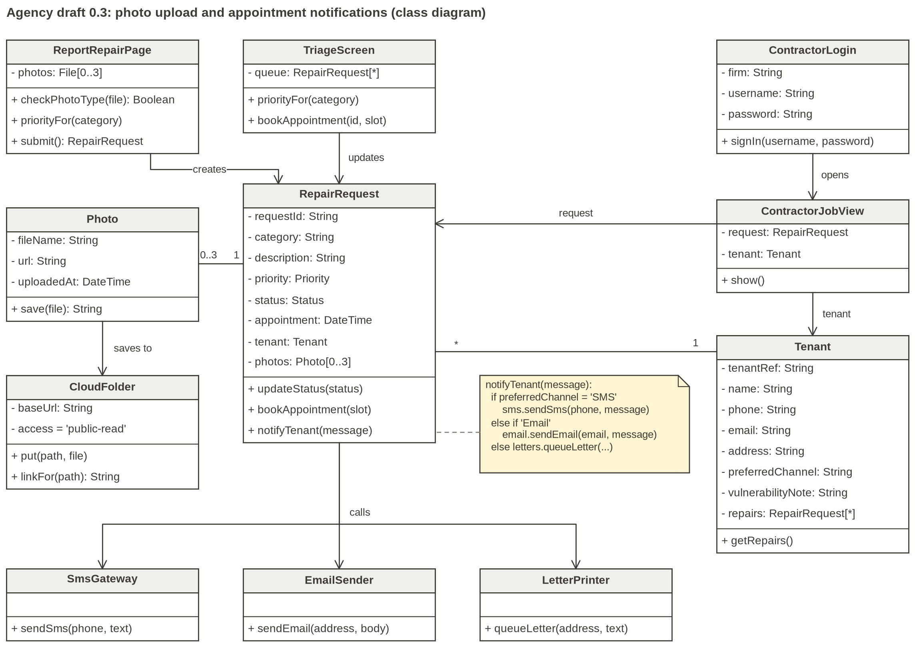
Figure 1. The agency's class diagram (draft 0.3); also page 1 of the starter file.

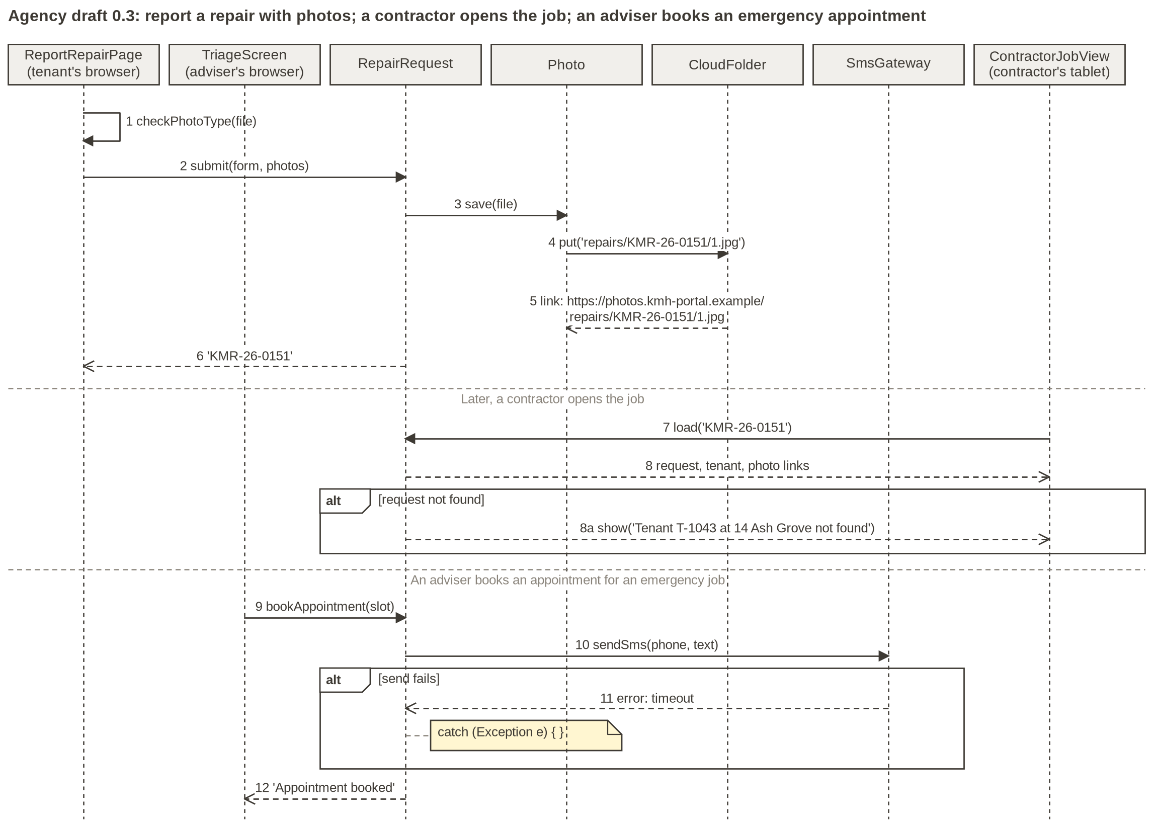
Figure 2. The agency's sequence diagram (draft 0.3); also page 2 of the starter file.

Part B: Reading a design

Four passes
Read the design four times, with one question each time. Log each weakness as you find it.
Pass | Ask | Where to look
1 Trace each requirement | For each of SEC-1 to SEC-6, DP-1, DP-2 and MNT-1 to MNT-3: which class, message or note meets it? No home is a gap; a design that does the opposite is a weakness. | The Part A checklist beside the diagrams
2 Follow the personal data | Where is personal data created, stored, shown and sent? Does every receiver need every field? Which fields are special category data? | Attributes, links and what each class receives
3 Find the trust boundaries | Where does data cross from browser to server, from Kestrel Moor to another organisation, or from the internet to storage? What is checked at each crossing, and on which side? | Where each part runs; arrows between them
4 Walk the failure paths | For each step: what if it fails, times out or receives bad input? Who finds out, and how quickly? | Messages, alt frames and notes

Severity scale
Rate on the harm, not on how hard the fix is. A spread of severities tells the author what to fix first.
Severity | Use it when | Example from a different system
High | Likely harm to someone's safety, exposure of special category data (health, disability), or one person able to act as or see another. | Anyone can mark their own rent account as paid.
Medium | Real harm that is less likely or more contained, or a change that will be slow and error-prone. | A reminder text shows a debt on a phone's lock screen.
Low | An inconvenience or a small exposure with an easy workaround. | A receipt shows the full account number where the last four digits would do.

Worked example: a rent reminder design (a different system)
A nightly job texts tenants in arrears: 'Ms R. Patel, account 4471-22 is in arrears. Pay now at rent.example/pay'. The tenant pays on the provider's page, and the provider then calls /rent/paid?account=4471-22, which marks the account as paid. Two log rows for that design:
Weakness: what and where | Requirement or principle it breaks | Risk, and severity
Reminder text shows name, account number and arrears on the lock screen | Data minimisation | Debt disclosed to anyone holding the phone; possible financial abuse. Medium: real harm, limited to people near the phone
The /rent/paid callback marks an account paid without checking it came from the provider | Validate on the server (trust boundary) | Anyone who finds the URL can clear their own arrears; records become wrong. High: direct financial loss, easy to exploit

Your log for the agency's design will contain different weaknesses: it is a different system with its own requirements.

Part C: Pattern cards
Each card uses a leisure-centre booking system, not Kestrel Moor. Your job in Activity 2 is to decide which problems in the agency's design are recurring problems, and which pattern, if any, solves each one.

Strategy
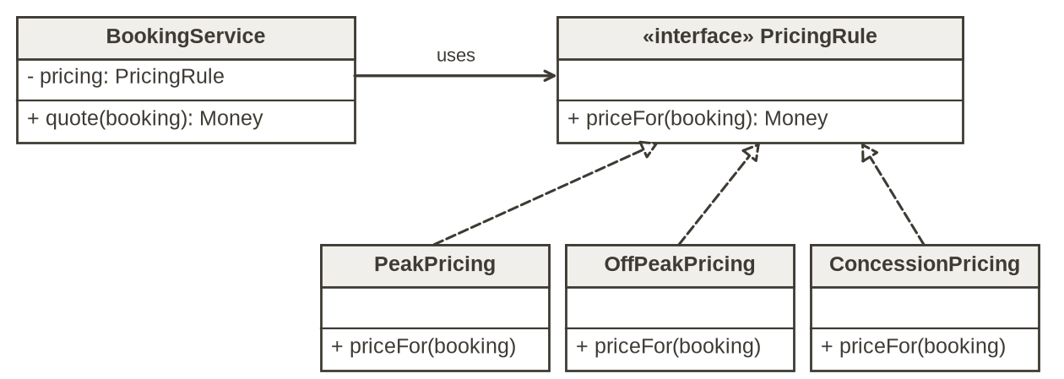
• Problem: a task can be done in several ways, the ways multiply, and the code that uses them should not have to change.
• Structure: a context class holds a reference to an interface; each way of doing the task is a class that implements it.
• Example: BookingService asks its PricingRule for a price; PeakPricing, OffPeakPricing and ConcessionPricing implement it. Junior pricing is one new class.
• Helps: maintainability (add a rule without editing callers) and security (one rule object on the server works out the price).
• When not to use it: one fixed way that is unlikely to change; or a passed function does the job.

Observer
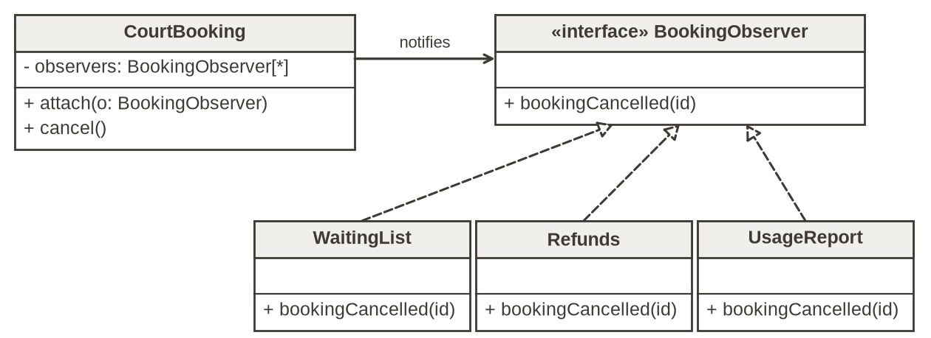
• Problem: when one object changes, several others must react, and the list of reactions grows.
• Structure (Gamma et al.): the subject keeps a list of observers that share one interface, and calls each one when it changes. It knows only the interface.
• Example: CourtBooking.cancel() calls bookingCancelled(id) on each attached BookingObserver: WaitingList, Refunds and UsageReport.
• Helps: maintainability (a new reaction is a new observer; the subject is untouched) and data minimisation (pass an ID; each observer fetches what its role allows).
• When not to use it: one reaction that will never grow, or steps that must run in a fixed order. A related pattern, publish and subscribe, puts an event bus between the two sides so neither knows the other.

Factory Method
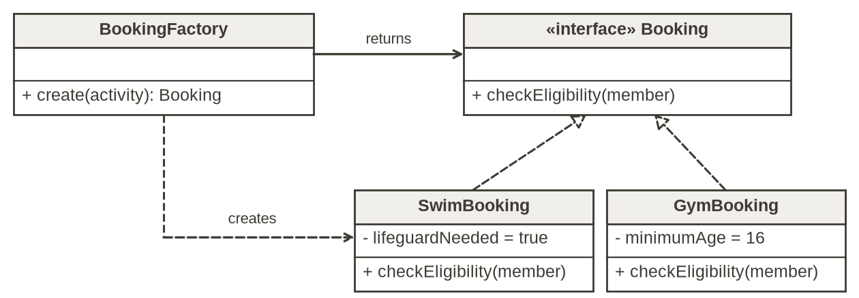
• Problem: code must create one of several related kinds of object, and each kind has its own creation rules.
• Structure (Gamma et al.): a creator declares a factory method and its subclasses decide which class to create. A variation the book also describes, the parameterised factory method, takes a parameter naming the kind; many teams call this a simple factory.
• Example (parameterised): BookingFactory.create(activity) returns a SwimBooking or a GymBooking, each built with its own checks.
• Helps: controlled creation (no screen can build a booking that skips the checks); a new kind is a new class and one line in the factory.
• When not to use it: one kind of object with a simple constructor.

Repository
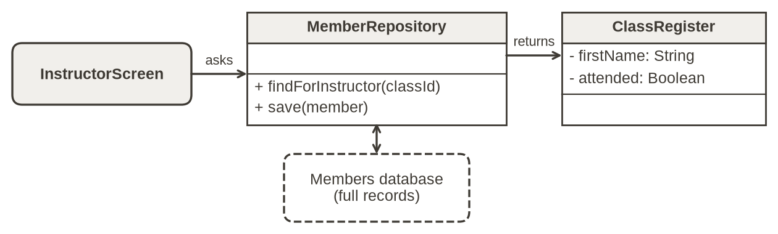
• Problem: data access is scattered across screens, each with its own query and its own idea of which fields to return.
• Structure (Fowler; Evans): a collection-like object; callers ask it for domain objects by meaning, such as findForInstructor, and it deals with the database.
• Example: MemberRepository.findForInstructor(classId) returns a ClassRegister with first names and attendance only.
• Helps: security (each role's query, and the fields it returns, is written once), maintainability (change the database without touching callers) and testing.
• When not to use it: the framework's data access is already simple. Who may see what is decided by the access rules; the Repository carries that decision out in its queries, and holds no other business rules, such as pricing or priority.

draw.io quick guide
1 Download Starter Files.zip, unzip it and save the .drawio file to your device. At app.diagrams.net choose Device, then Open Existing Diagram.
2 Pages (tabs at the bottom): Agency class diagram, Agency sequence diagram, and Your revised design, which already holds a copy of the agency's classes.
3 New class: type 'class' in the shape search box and drag in a UML Class; double-click to edit its text.
4 Interface: a class named «interface» Name. Implements: a dashed line with a hollow triangle at the interface (Format panel, Line end).
5 Links: hover over a class and drag one of its blue arrows to another class. Labels: a Note shape (search 'note') beside each change.
6 Save: File, Save as, Device. PNG: File, Export as, PNG.
No draw.io? Draw boxes in PowerPoint (Insert, Shapes) or on paper, photograph the result and post it in your breakout chat.

Part D: Writing an architecture decision record (ADR)
An ADR is a short record of one significant decision: why it was made, what was decided and what it costs. Michael Nygard's format (2011) has five sections; many teams add 'alternatives considered'. Teams keep ADRs in the code repository, numbered, and never delete them: a replaced decision is marked Superseded and points to its replacement.
Section | What it holds | Tips
Title | The decision, as a short phrase | 'Use X for Y', not a topic word such as 'Notifications'
Status | Proposed, Accepted, Deprecated or Superseded | Yours is Proposed until others agree it
Context | The problem and the forces: requirements, constraints, people | Neutral words; name the requirement and who is affected
Decision | What we will do | Full sentences starting 'We will'; name the pattern, if there is one, and where it applies
Alternatives considered | Options rejected, and why | At least two. Not in Nygard's original five sections, but widely added
Consequences | What becomes easier and what becomes harder | Security, maintainability and named stakeholders; at least one cost

One decision per ADR. A developer who joins next year should be able to act on it without asking you.

Worked example: ADR 7 (a different system and decision)
Section | ADR 7
Title | ADR 7: Put the rent payment provider behind our own PaymentGateway interface
Status | Accepted (Kestrel Moor's rent system, which is not part of the portal)
Context | Each rent screen that takes money calls the payment provider's API directly. Finance may switch provider when the contract ends, and the income team is small. Card details must never pass through Kestrel Moor's servers.
Decision | We will define a PaymentGateway interface (takePayment, refund, paymentStatus) with one implementing class for the current provider. Every rent screen will call PaymentGateway, never the provider. Card details will be entered on the provider's hosted page.
Alternatives considered | Keep direct calls: rejected, because a switch would mean editing and retesting every screen. A payment platform over several providers: rejected for now, because it adds another processor of tenants' data, fees and a contract.
Consequences | Security: one place for logging and checking responses; card data stays with the provider. Maintainability: a new provider is one new class, but the interface is one more thing to test. Stakeholders: finance can switch with less risk; tenants see no change; the hosted page limits how far the payment screen can be styled.

Sources
• Gamma, E., Helm, R., Johnson, R. and Vlissides, J. (1994) Design Patterns: Elements of Reusable Object-Oriented Software. Addison-Wesley.
• Fowler, M. (2002) Patterns of Enterprise Application Architecture. Addison-Wesley; Repository entry at martinfowler.com (accessed October 2026).
• Evans, E. (2003) Domain-Driven Design: Tackling Complexity in the Heart of Software. Addison-Wesley.
• Nygard, M. (2011) Documenting Architecture Decisions. Cognitect blog, 15 November 2011 (accessed October 2026).
• UK GDPR Articles 5, 9 and 25, legislation.gov.uk (accessed October 2026; Article 25 amended from 5 February 2026 by the Data (Use and Access) Act 2025, section 81).
• Information Commissioner's Office, guidance on special category data, ico.org.uk (accessed October 2026).
• Ministry of Housing, Communities and Local Government, Awaab's Law: Guidance for social landlords, and Awaab's Law in the social rented sector, GOV.UK (accessed October 2026).

